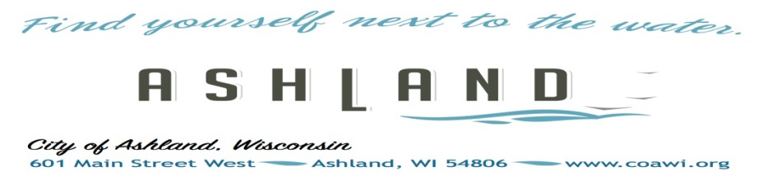
UTILITY AUTO PAY
ENROLLMENT OR
CHANGE FORM
City of Ashland Utilities offers Direct Pay at NO CHARGE for your water/sewer/garbage. Please complete the information below and return to City Hall. Payments will be made and taken from your bank account on the due date, which is on or around the 10th of every other month. If you have multiple accounts you can indicate all of them on this form. Customers currently using auto pay through Payment Service Network (PSN) will need to cancel directly with PSN. City staff does not have the capability to do this on behalf of the customer.
___ I wish to sign up for Auto Pay. Complete and sign the enrollment form below. Allow 3 weeks for activation
___ Change Banking Info.
___ I wish to stop Auto Pay (30 day written notice is required)

Utility Account Information (Please continue on back if more than one account)

Customer Name:
Address:
Phone #:
Utility Account #
Property Address

Payment Information Note: Payment amounts will vary. If you do not receive your bill
by the 25th of the bi-monthly billing cycle, contact us immediately at 715-682-7071.

Financial Institution Information

Name: Phone #
Address:
Bank Routing Number Bank Account Number
____ Checking Account –attach a voided check ____ Savings Account – attach a deposit ticket

Terms of Agreement
Utility customers of the City of Ashland by signing the Direct Pay Enrollment form
agree to the following Terms of Agreement:
I authorize the City of Ashland to automatically debit the account listed for my bi-monthly utility services. I understand that this preauthorized payment will continue bi-monthly for the amount due and that the payment amount may vary. A customer using the automatic payment system is responsible for maintaining sufficient funds in the customer’s deposit account on the dates on which payments are drawn. Any customer having insufficient funds in the customer’s deposit account or a closed account twice within a six-month period shall be disqualified from using the automatic payment system for the subsequent twelve (12) month period. During this period, the account must be paid by cash or certified funds. Account holder will be responsible for all fees charged by their financial institute and the utility for insufficient funds.

Information provided on this form will be used solely for purposes of processing payments on utility customers account and for no other purpose. THERE IS NO CHARGE TO OUR CUSTOMERS FOR THIS SERVICE. If the Utility’s financial institution changes their policy and assesses a fee for this service, Public Service Commission rules require the Utility to pass these fees on to the customer. Written notice will be provided to the customer prior to assessing any processing fees.
FOR OFFICE USE ONLY
START DATE
RCVD DATE/BY
NOTES:

I (utility customer) may revoke the preauthorized payment plan at any time with thirty (30) days written notice to the City of Ashland Utility Billing Department.

X
CUSTOMER SIGNATURE
DATE

