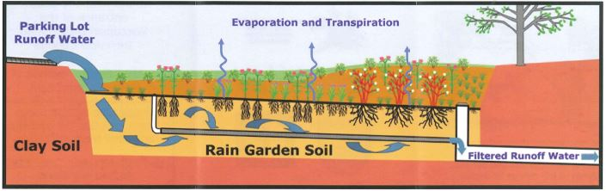
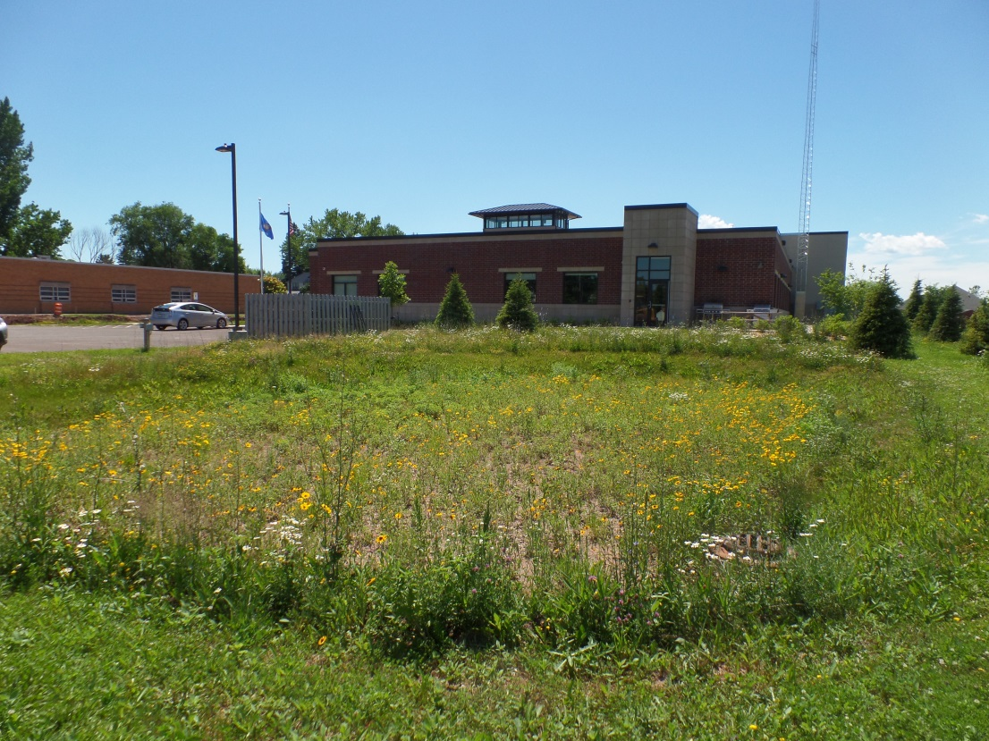

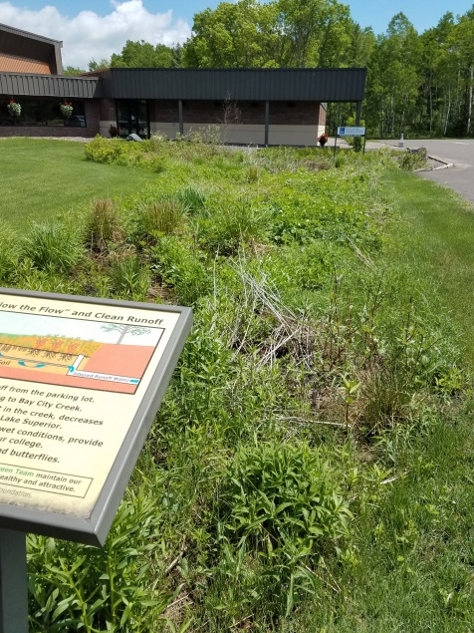
Rain Gardens versus Retention Ponds
Retention ponds are depressions with drains near the top of the pond, providing an indentation that is more consistently wet and filled with water.
An example of a retention pond is near the new fire station – they have created a large, landscaped area, where, if there is runoff from the parking lot or surrounding roads, the water is diverted into this retention pond. The water will then slowly soak in to the soil as standing water subsides.
This feature is a storm water control mechanism that filters the water as it drains, but it is designed to keep the water contained until it can be soaked into the surrounding soil.
Rain Gardens are ditches or indents planted with native, water-loving plants, with a drain at the lowest point of the depression.
They are designed to “slow the flow” of the water, filtering it through multiple plant species with the water not directly absorbed moving towards creeks and rivers.
An example of a well-designed Rain Garden is next to the WITC parking lot. They have created a system that filters out pollutants and debris from 82,000 square feet of runoff from the parking lot and the building’s roof.
Slowing the Flow is an essential storm water management tool as it prevents our storm water systems from being overwhelmed with water all at once. It also creates ways for filtration of pollutants and sediments to make the storm water cleaner before reaching the creeks and Lake Superior.

